IT457 Cloud computing

Assignment - 3

Abhinav Agarwal (202101040)

**Complete the following tutorials**:

1. Complete the following tutorial about pictures and blob storage:

Environment Variables: -

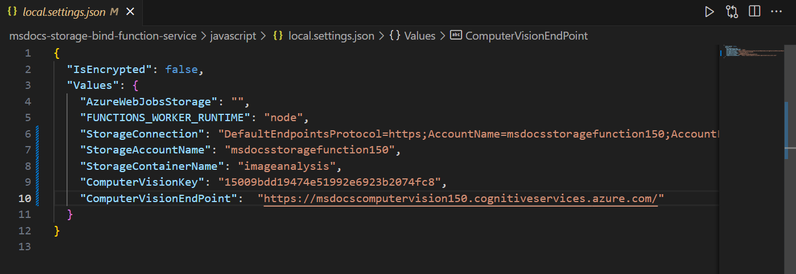

Function App Published: -

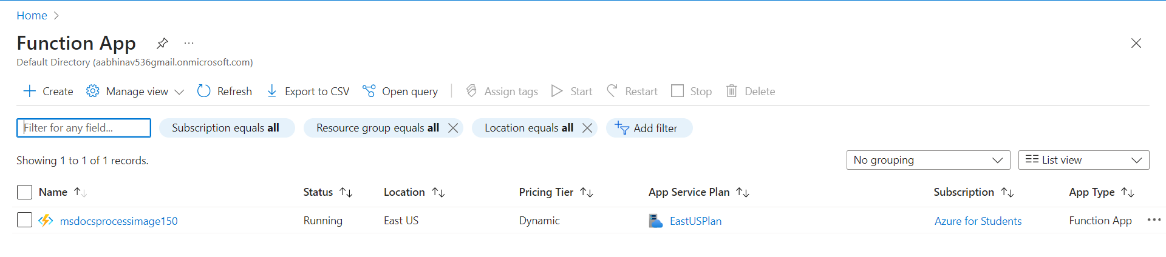

Container and its contents: -

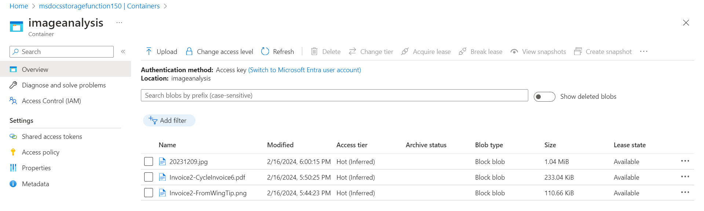

Overview: -

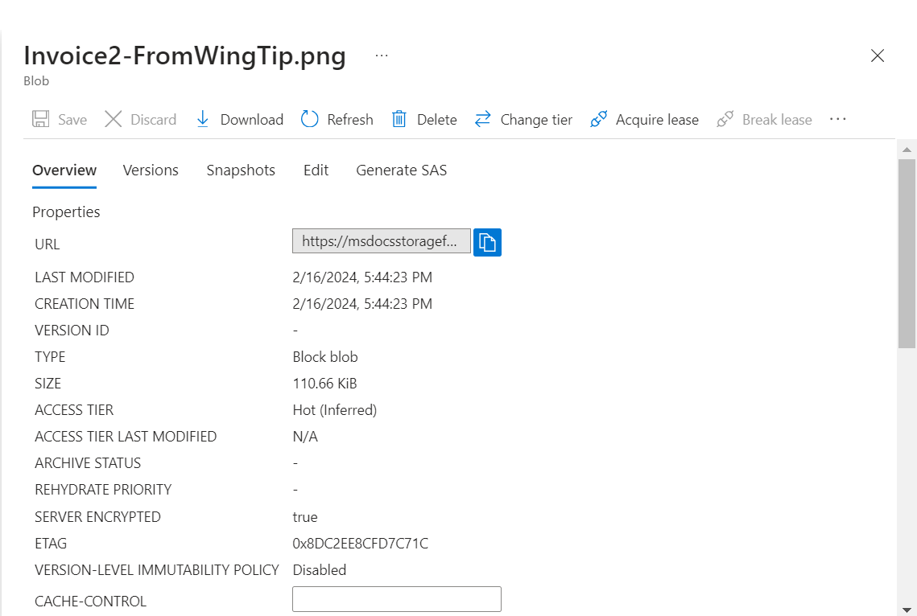

Outputs of contents stored in blob storage: -

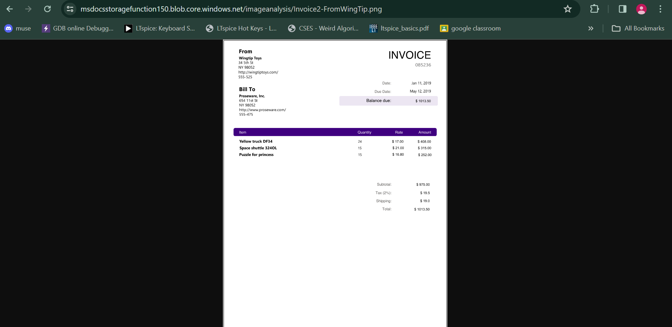

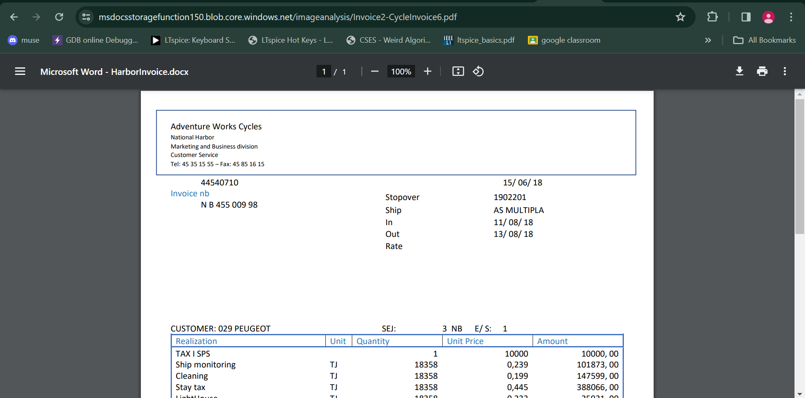

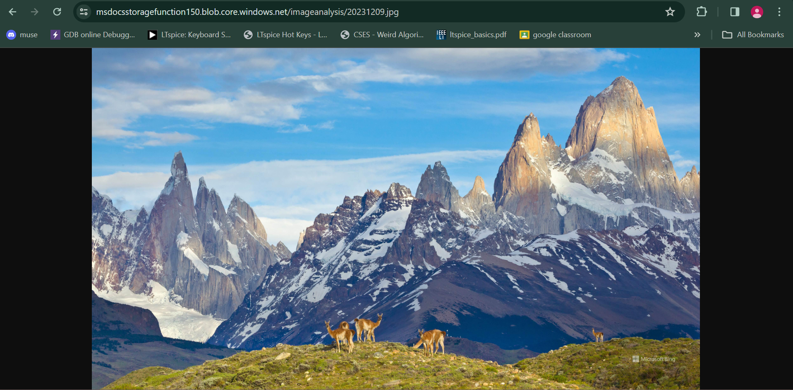

2. Complete the following tutorial about static content website hosting:

Container:

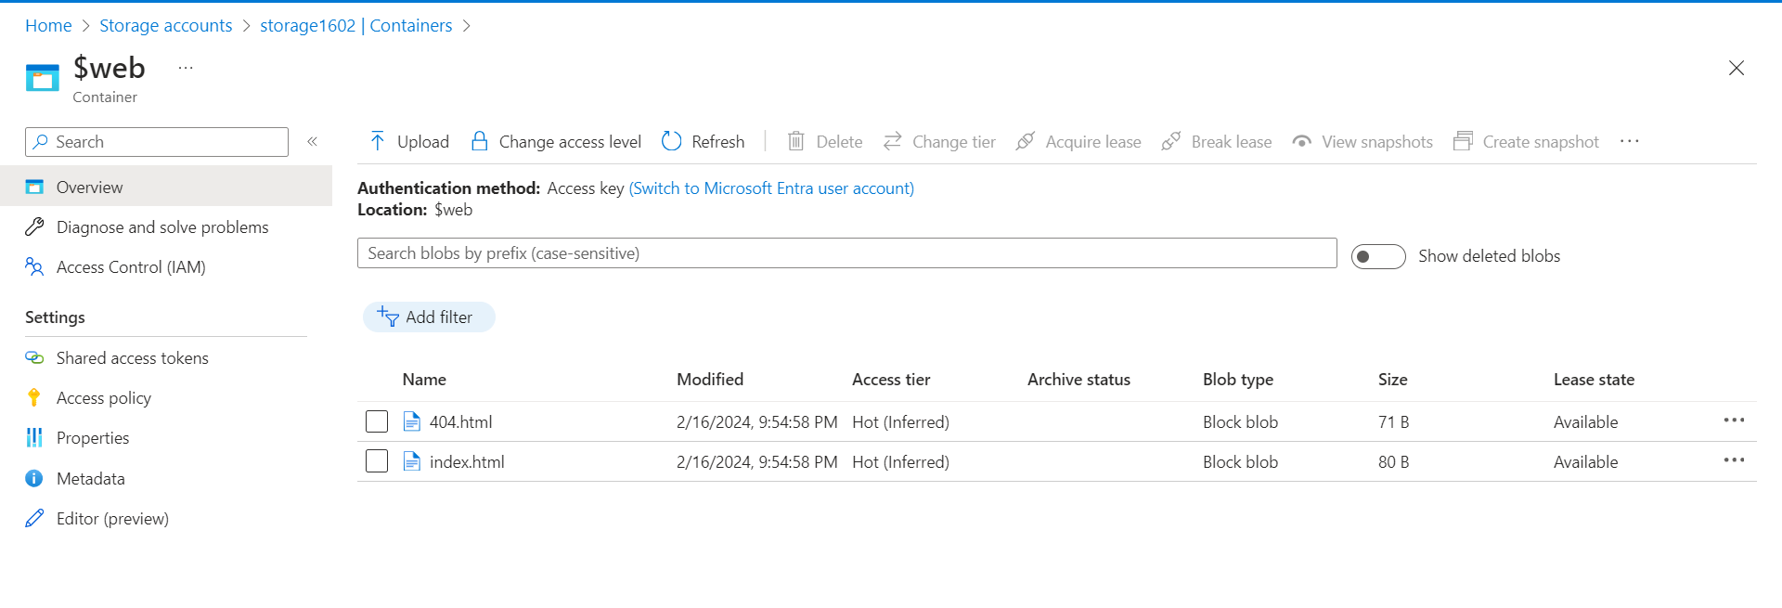

Codes:

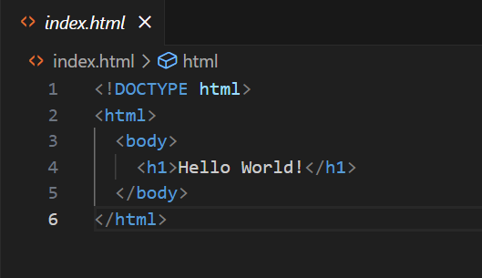 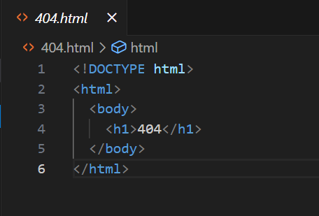

Output:

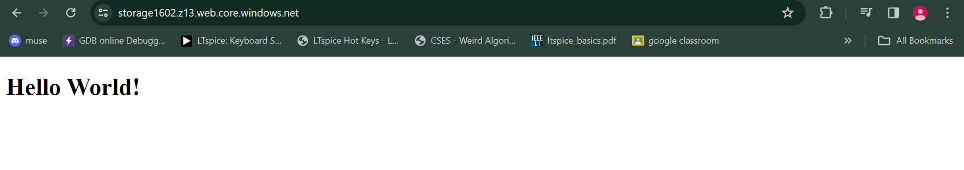

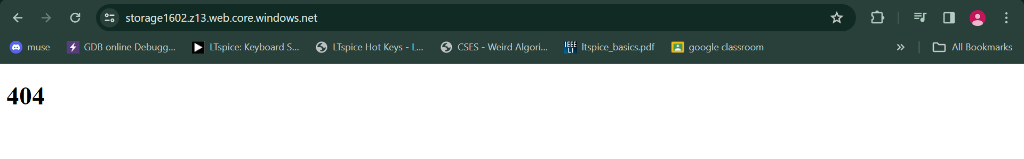

3. Complete following tutorial for designing application with high availability

Initially: -

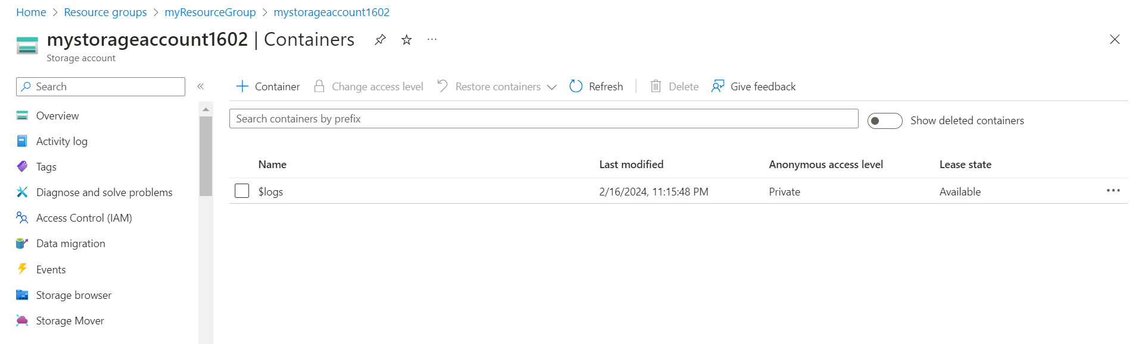

Result after running code from v12 in Visual studio: -

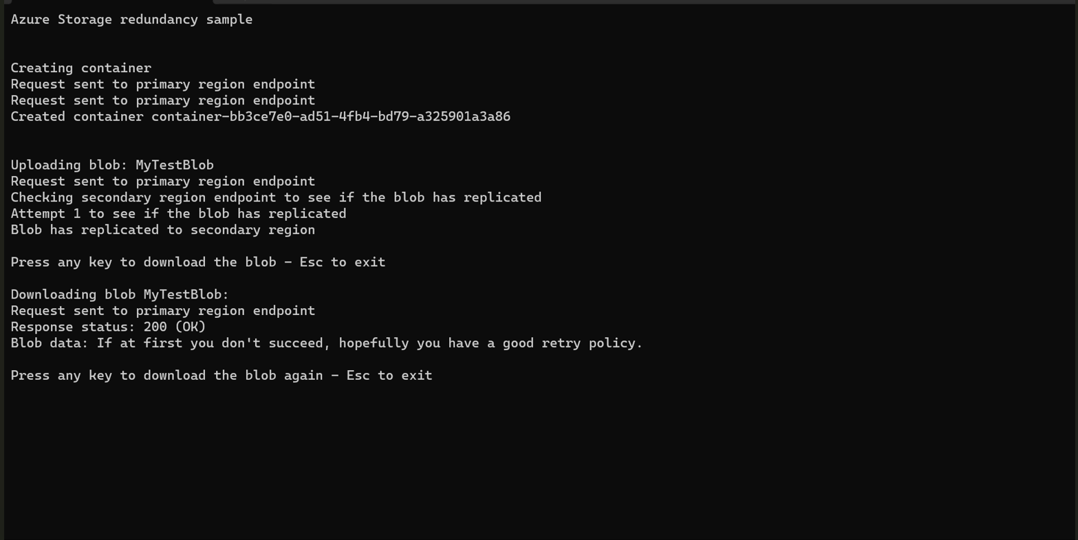

Blob replicated to secondary region, so high availability.

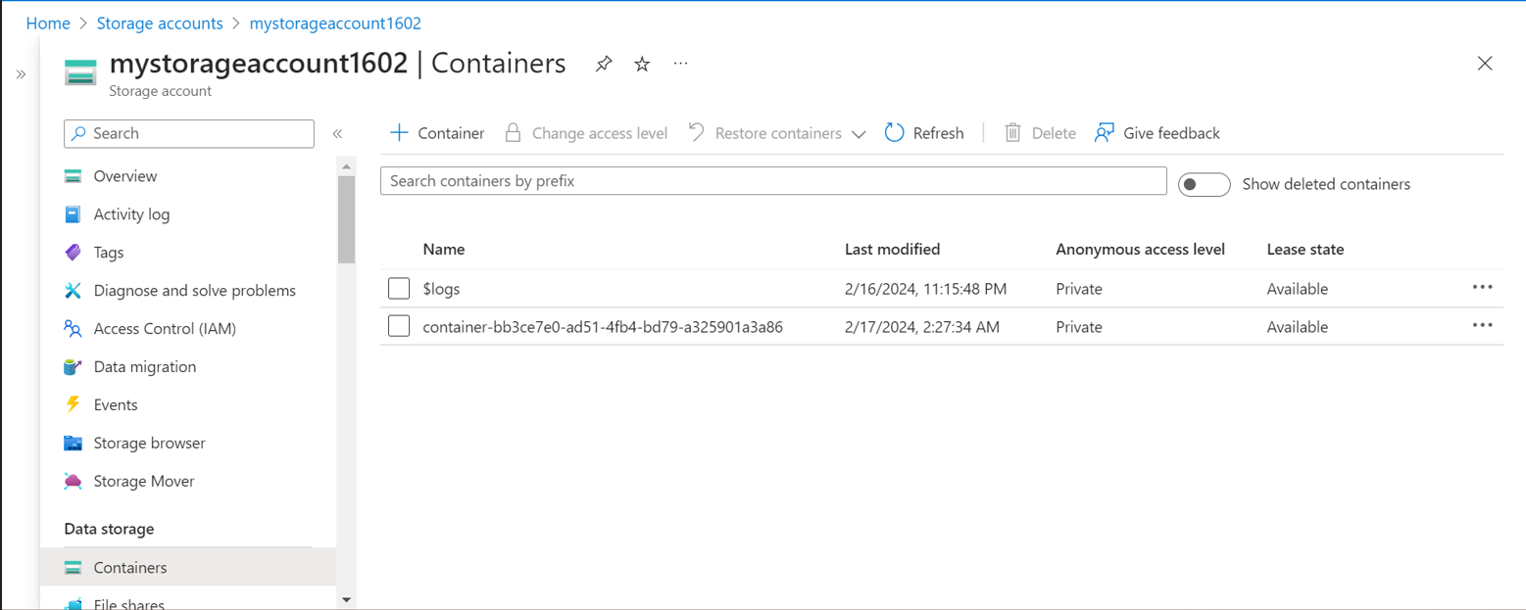

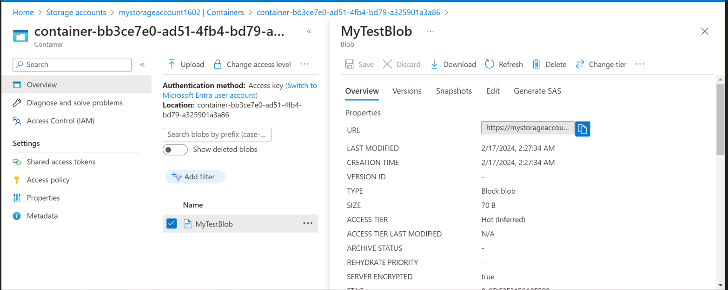

4. Complete the tutorial to add role assignment to blobs:

Two text files in blob storage with different tags: -

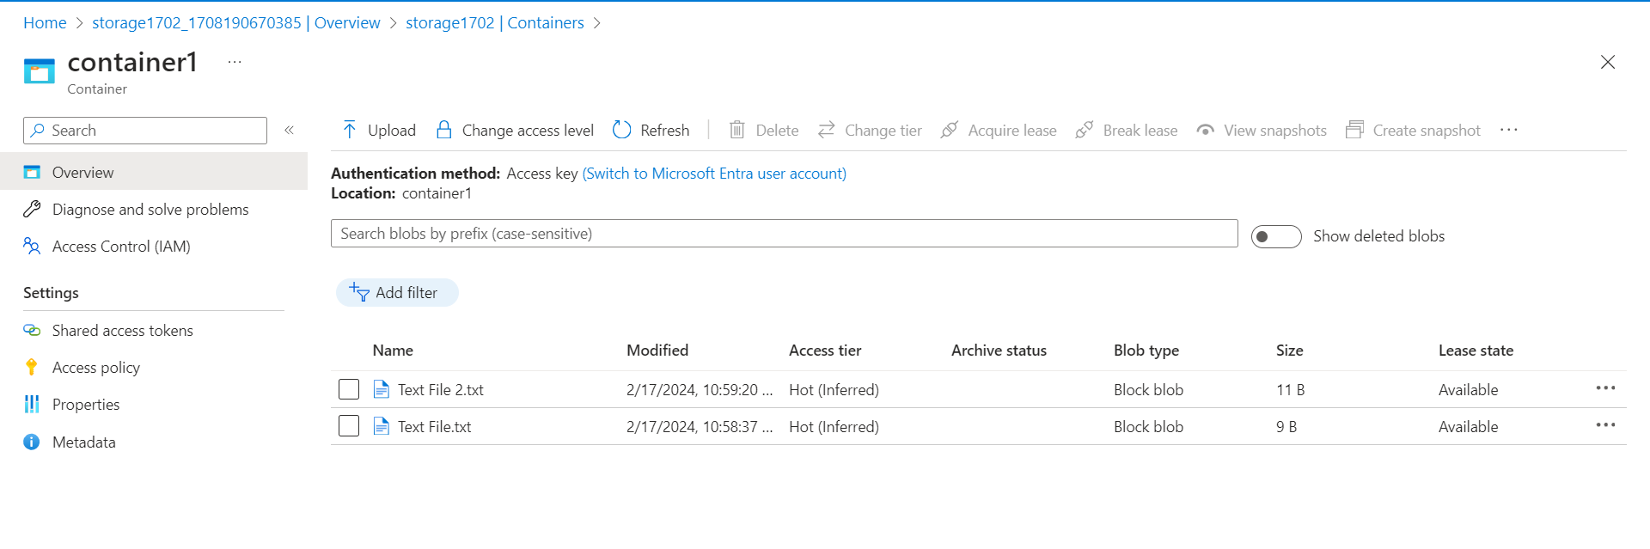

Assigning Role of storage blob data reader: -

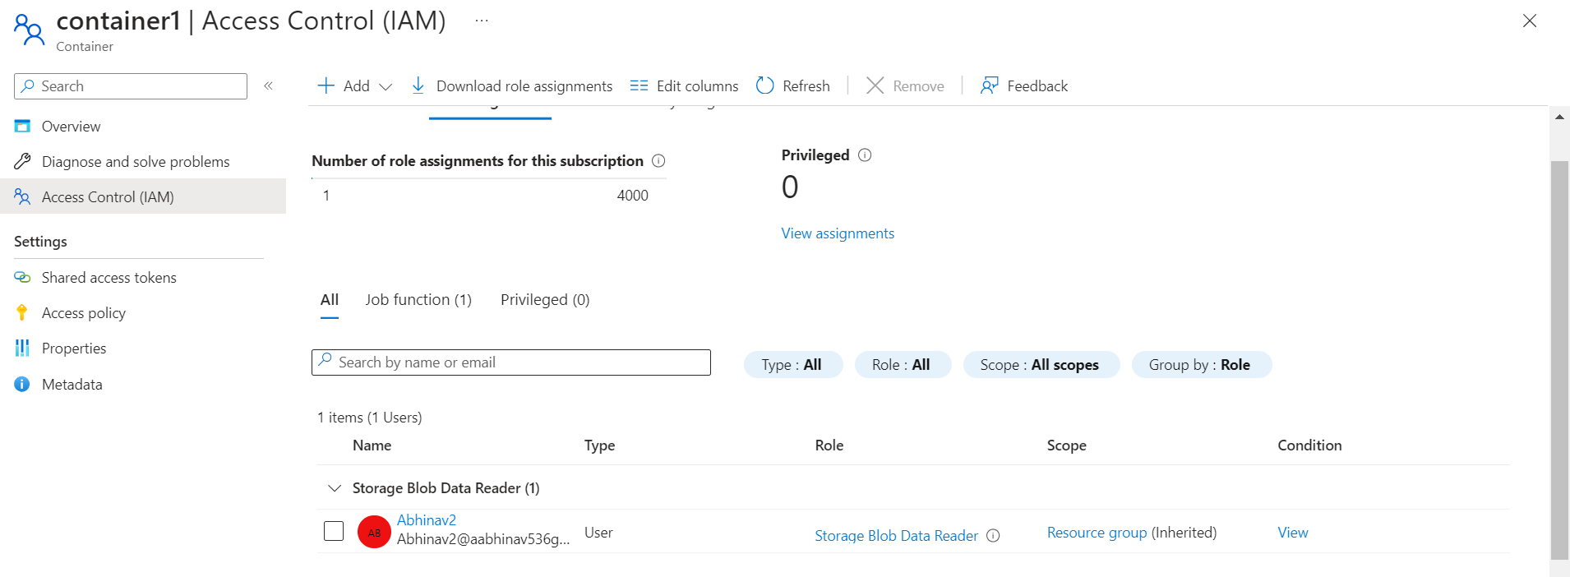

Result: -

User able to access the file with the tag for which storage blob read role was assigned, whereas file with other tag not accessible.

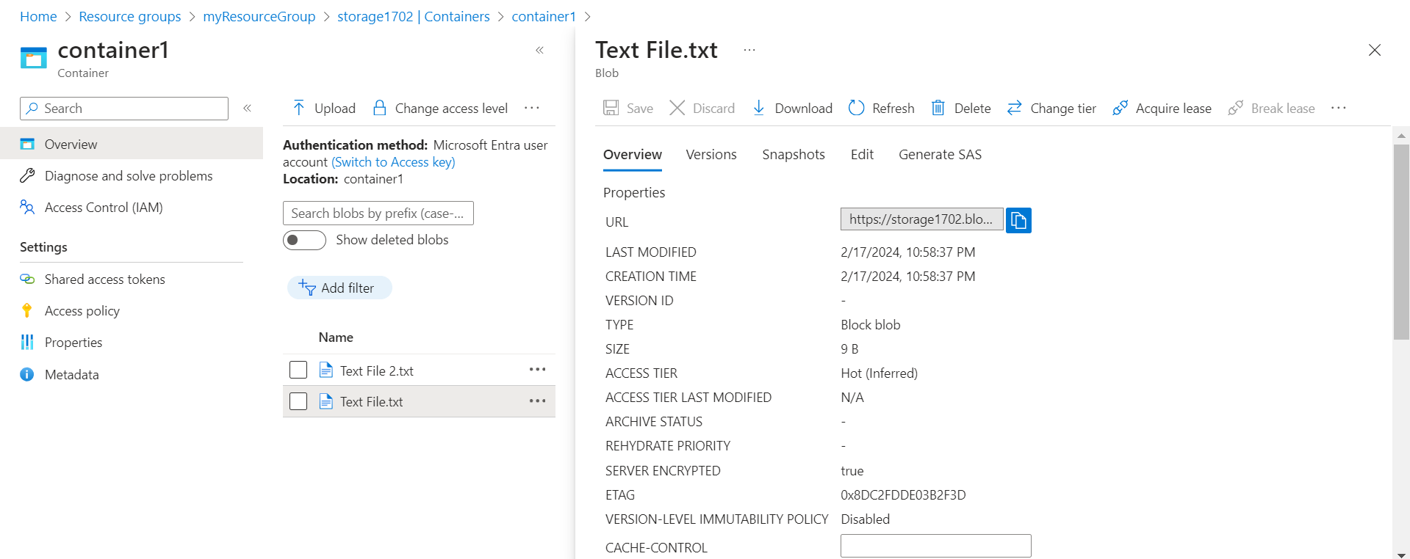

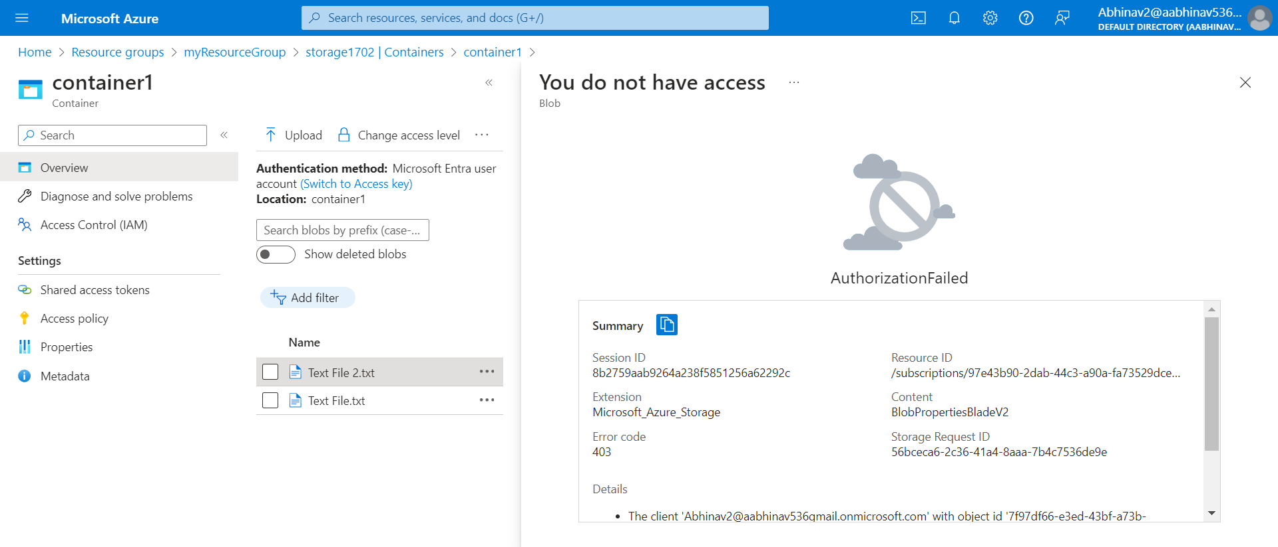

5. Complete the tutorial to deploy cloud witness: -

Access Keys:

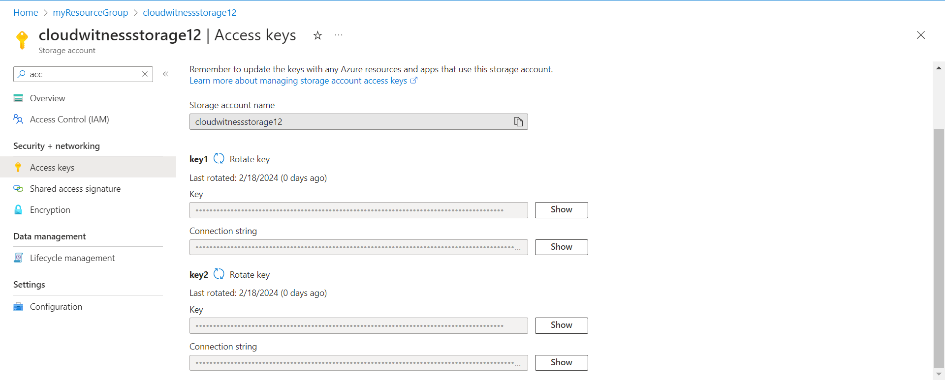

VM:

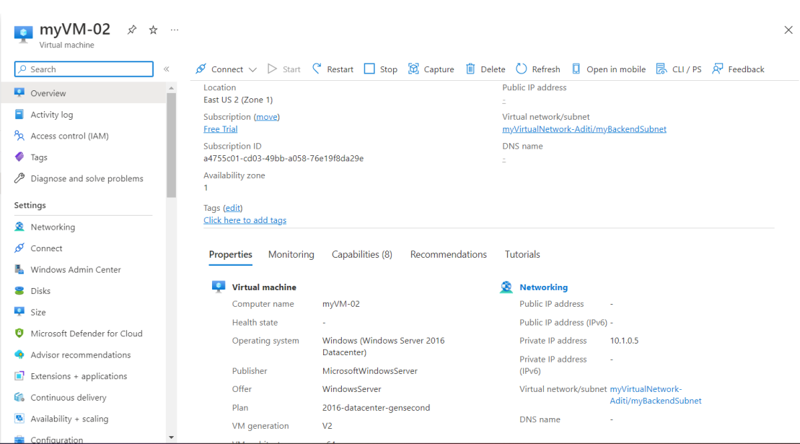

Cloud Witness:

